

**COMSATS University Islamabad**

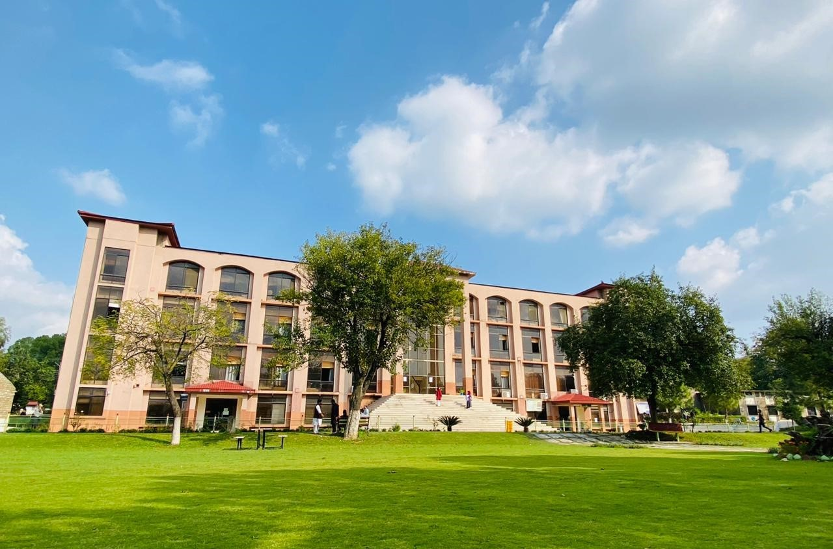 **(Abbottabad Campus)**

**NAME: FATIMA AFTAB**

**REGISTRATION NO: FA21-BSE-088**

**ASSIGNMENT: LAB MIDTERM**

**DATE OF SUBMITTION: 24th May 2024**

**SUBMITTED TO: Mukhtiar Zamin**

# Task#1:

CFG of given Algo 1(Reverse an Array)

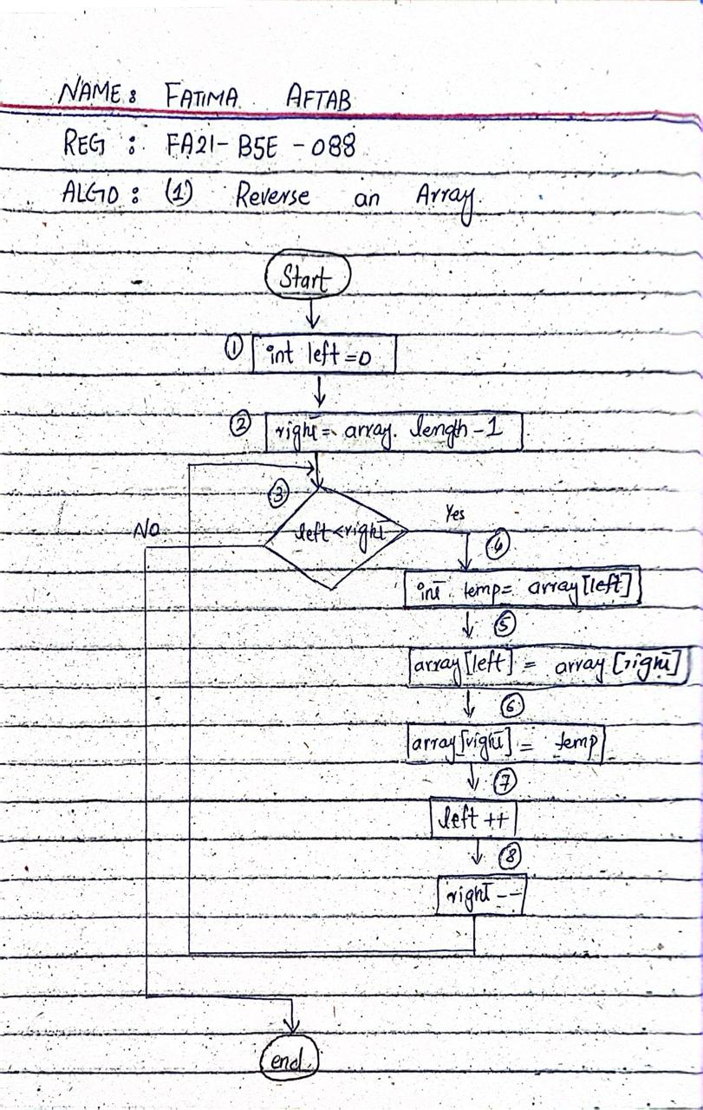

# Task#2:

## 2.1. Test Input Data

|  |  |
| --- | --- |
| **Path** | **Input Data** |
| 1,2,3,4,5,6,7,8,3 | Array= {1,2,3,4,5} |
| 1,2,3 | Array= {1} |

## 2.2. Test cases of Algorithm 1 (Reverse an Array)

|  |  |  |  |  |  |
| --- | --- | --- | --- | --- | --- |
| **T_ID** | **Description** | **Input** | **Expected Outcome** | **Actual Outcome** | **Status** |
| TC_01 | To reverse the element of given array | Array= {1,2,3,4,5} | 5,4,3,2,1 |  |  |
| TC_02 | To not reverse array for array having single element | Array= {1} | 1 |  |  |

# Task#3:

Junit testing of given Code using IntelliJ

## 3.1. Code to be tested (Algo)

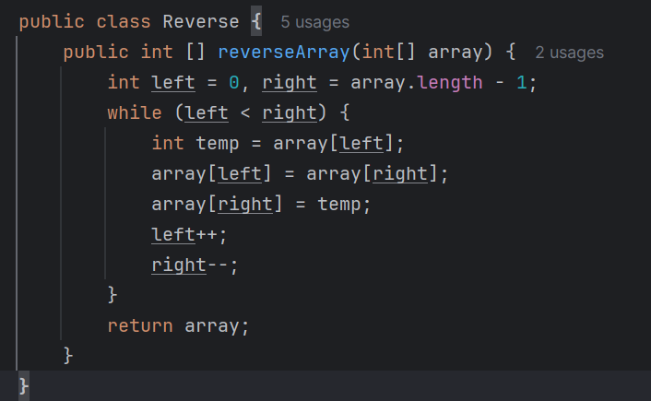

## 3.2. Test Cases:

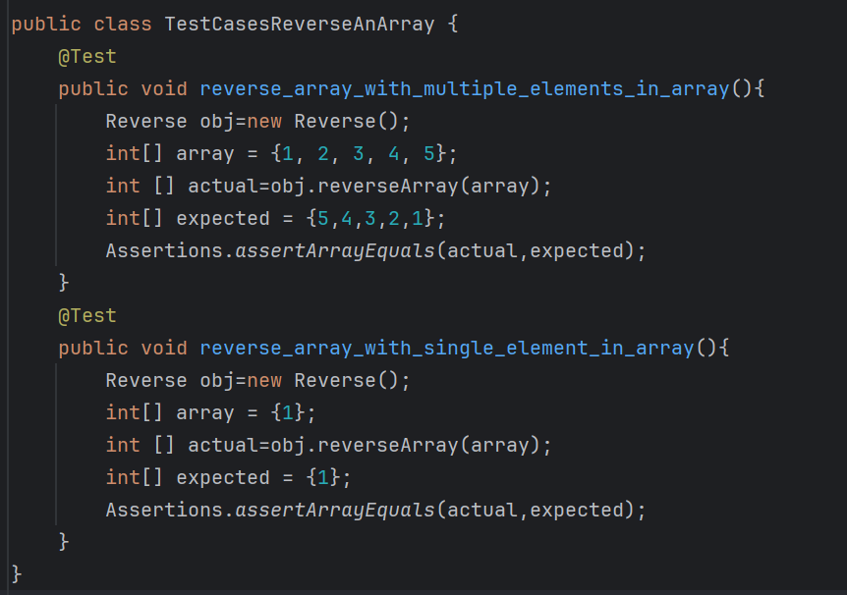

## 3.3. Actual Outcomes of Testcases:

## 3.4. Table Updated

|  |  |  |  |  |  |
| --- | --- | --- | --- | --- | --- |
| **T_ID** | **Description** | **Input** | **Expected Outcome** | **Actual Outcome** | **Status** |
| TC_01 | To reverse the element of given array | Array= {1,2,3,4,5} | 5,4,3,2,1 | 5,4,3,2,1 | Pass |
| TC_02 | To not reverse array for array having single element | Array= {1} | 1 | 1 | Pass |